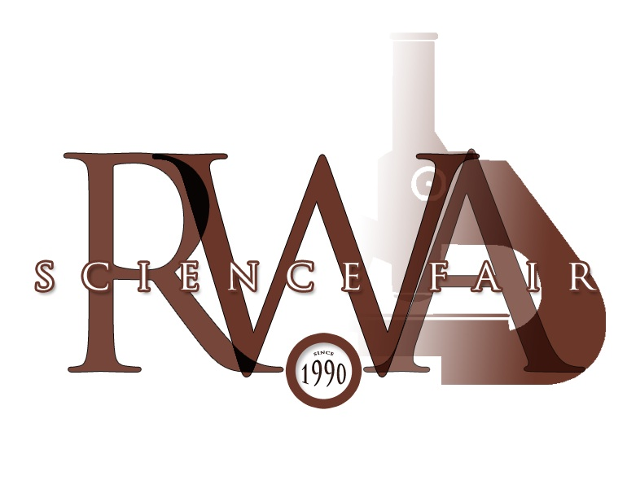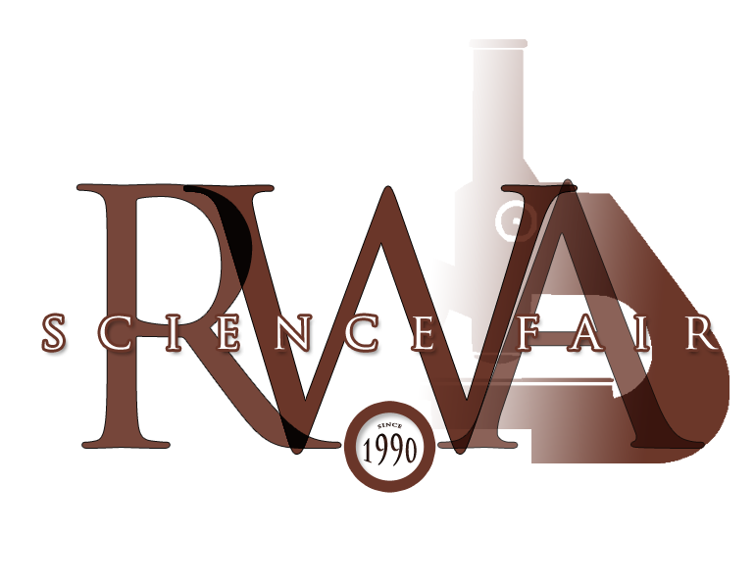

RWA Science Fair - February 11, 2016
Donation Request Form

Please complete the form below and bring it to the RWA school office/Science Fair mail slot or mail it to: Royal West Academy, Jennifer Pevec (Science Fair Coordinator), 189 Easton Ave., Montreal West, P.Q. H4X 1L4
All cheques are payable to Royal West Academy.

Date: _____________________________________

Name:________________________________________________________
(Company/organization/university/college/individual/family)

Contact Person: _________________________________________________
(If applicable)

Address:________________________________________________________________
Number and name of street

________________________________________________________________________
City/province Postal code

E-mail: _________________________________________________________________

Phone number:__________________________________________________________

Prize included:__________________________________________________________
(Example: Cheque/Cash amount or Gift Certificate/amount)

Field of Study (Optional – you can request that it be awarded to a particular field of study or leave it blank so it goes where it is most needed):

________________________________________________________________________

Name of Prize (Optional – Example: “Family Smith/Tremblay Physics Award” or “Company ABC Award for Math” or it can remain anonymous)
________________________________________________________________________

Grade Level (Optional):

Please place an “X” on the appropriate line below:

Junior (grades 8/9) ____ Senior (grades 10/11) ____ Either____

Thank you for your support.
A receipt will be provided to you.

Jennifer Pevec,
Coordinator, RWA Science Fair
rwasciencefaircoordinator@gmail.com

