Royal West Academy Grade 8 Ski Trip
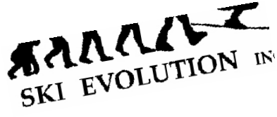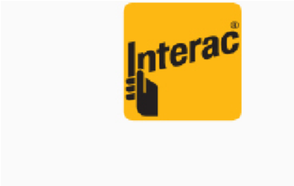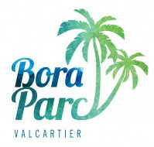
More information can be found on Schoology using the following GROUP code: KWR5X-56V44
Students attending the Royal West Grade 8 Ski Trip will be staying at
Stoneham Hotel
, situated at
the base of
Stoneham Mountain Resort.
Each room

will accommodate 4 students. The rooms have color T.V. and private bathroom.
Breakfast, lunch and dinner are provided. Students must bring their own lunch on the first day.
All students will receive lessons throughout the trip. This trip is an excellent opportunity for begin
-
ner skiers to learn a new sport. Only intermediate & advanced snowboarders will be accepted.
All students must wear helmets while skiing & riding. Snowboarders should also wear wrist guards.
One evening will be spent tubing at
Villages Vacances Valcartier
and another evening will be spent
at the new indoor waterpark (
Bora Parc
)
at Valcartier.
starting at
$600
February 5-8, 2019
Includes:
Bus Transportation
Ski Pass (4 days)
Breakfasts, lunches & dinners
Accommodation (3 nights)
Ski instruction (15 hours)
Night activities
All taxes
Limited Space Available !!
Registration deadline: October 12th 2018
For additional information please contact:
Mme Belina
cbelina@emsb.qc.ca

RWA Grade 8 Ski Trip Info

Trip dates: | February 5-8, 2019
Registration deadline: | October 12th, 2018
Destination: | Stoneham
Lodging: | Stoneham Hotel (418) 848-2000
Bus departure from: | RWA
Bus transportation: | By Deluxe Coach
Departure time: | Feb 5 at 8:00 a.m.
Return to Montreal: | Feb. 8 at approximately 4:30 p.m.
Cost: | $600.00
Payment: | Please make your cheques payable to Royal West Academy and return all of the post dated cheques with your completed Registration Form to Mme Belina by October 12th. Please write your name, homeroom & "Grade 8 Ski Trip" on the front of your cheques.
Payment Schedule: | October 12th , 2018 $200.00  November 30th , 2018 $200.00
 | January 8th , 2019 $200.00 (+ equipment rental if required)

A $15 service charge will be assessed for any cheques returned by your financial institution.
The standard refund & cancellation policy for individual students is as follows:
- Greater than 45 days prior to departure = $100 cancellation fee
- 45 days to 15 days prior to departure = 50% refund of total trip cost
- less than 15 days prior to departure = no refund
Equipment Rentals: if you require equipment rentals, please add to your second payment. Helmets are compulsory for all students.

Application Form
Family Name |  | First Name |  | Homeroom

I am a... ❒ skier ❒ snowboarder

Level: ❒ Beginner ❒ Intermediate ❒ Advanced

I will bring my own helmet: ❒ yes ❒ no Note: all students must wear a helmet

Are you a vegetarian? ❒ yes ❒ no

Age: ________

If you require rental equipment please indicate below:

Height:_________ Weight:_________ Shoe Size:_______

❒ Skis ... add $113.00
❒ Snowboard ... add $131.00 Foot forward (snowboard only) R or L
❒ Helmet ... add $25.00

 | Payment Options:   Cash   Cheque   INTERAC (one payment only in school office) | Payment schedule:  October 12 $___________  November 30 $___________  January 8 + rentals $___________  $___________  Total $___________
All students will be required to sign and respect a Behavioral Contract. Any unacceptable behavior will result in a telephone call home informing you that your son/daughter will be sent home at your expense. There will be no refunds issued under these circumstances. I understand that you are acting as agents for the bus, tow, and/or restaurant service, if provided, and hereby waive any claims of any nature whatsoever. While you will provide competent staff and all reasonable precautions will be taken to avoid injury or damage I fully accept that accidents may occur and, consequently, I hereby waive, renounce and release you and/or the staff from any and all liabilities of any nature whatsoever. Moreover, I hereby waive, renounce and release you from any claim with respect to loss or damage of property.

Signature (Parent or Guardian) Date

